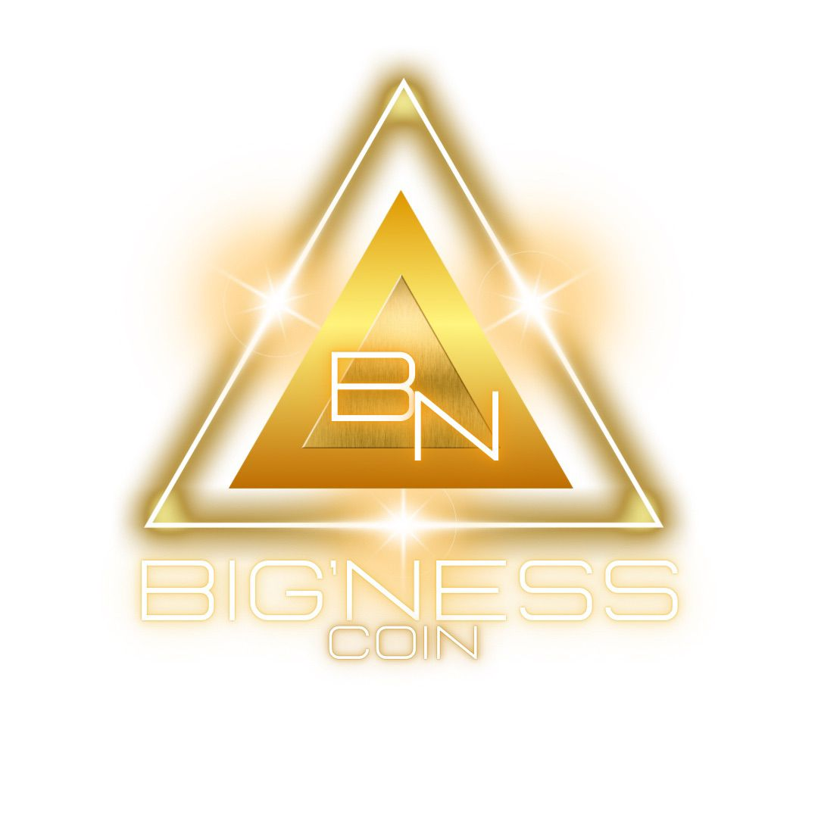BignessCoin: OTC Crypto Desk  
Client Onboarding Form

# Section 1: Personal Information

|  |  |
| --- | --- |
| Full Name |  |
| Date of Birth |  |
| Nationality |  |
| Residential Address |  |
| Contact Number |  |
| Email Address |  |
| Government ID (Passport/ID) |  |
| ID Number |  |

# Section 2: Business Information (If applicable)

|  |  |
| --- | --- |
| Business Name |  |
| Business Address |  |
| Type of Business |  |
| Registration Number |  |
| Country of Incorporation |  |
| Contact Person |  |

# Section 3: Financial Information

Source of Funds (Check applicable):

|  |
| --- |
| ☐ Salary/Wages ☐ Investments ☐ Business Profits ☐ Inheritance ☐ Consulting Fees ☐ Other (Please specify): |

# Section 4: Trading Preferences

Preferred Cryptocurrencies:

|  |
| --- |
| ☐ Bitcoin (BTC) ☐ Ethereum (ETH) ☐ USDT (Tether) ☐ Other (Please specify): |

Expected Monthly Trading Volume (USD): 

☐ Below $10,000  
☐ $10,000 - $50,000  
☐ $50,000 - $100,000  
☐ Over $100,000

# Section 5: Compliance and Legal

|  |
| --- |
| 1. Are you or your business subject to any legal actions? ☐ Yes ☐ No |
| If yes, please provide details: ____________________________ |
| 2. Are you a Politically Exposed Person (PEP)? ☐ Yes ☐ No |
| If yes, please provide details: ____________________________ |
| 3. Have you ever been involved in any financial crimes or regulatory violations? ☐ Yes ☐ No |
| If yes, please provide details: ____________________________ |

# Section 6: KYC and AML Compliance

|  |
| --- |
| Please provide the following documents for verification: |
| ☐ Copy of valid government-issued ID (Passport or ID card) |
| ☐ Proof of address (Utility bill, bank statement, etc., not older than 3 months) |
| ☐ Recent bank statement (for proof of source of funds) |
| ☐ Business registration documents (if applicable) |

# Section 7: Acknowledgment and Agreement

By signing this form, I confirm that the information provided is accurate and truthful to the best of my knowledge. I agree to comply with BignessCoin's Anti-Money Laundering (AML) and Know Your Customer (KYC) procedures. I also understand and acknowledge the risks involved in cryptocurrency transactions as outlined in BignessCoin’s Risk Disclosure document.

Client Signature: ______________________ Date: ______________________

# Section 8: For Internal Use Only

|  |  |  |  |  |  |  |
| --- | --- | --- | --- | --- | --- | --- |
| |  |  | | --- | --- | | Compliance Officer Name: |  | | Date of Review |  | | Status | ☐ Approved ☐ Pending ☐ Rejected | |